Marathwada Shikshan Prasarak Mandal’s

**Deogiri Institute of Engineering and Management Studies,**

**Aurangabad**

**Project Report**

**on**

**Attendance Management System**

Submitted By

**Aditya Rameshwar Kajale (46128)**

**Dr. Babasaheb Ambedkar Technological University**

**Lonere (M.S.)**

Department of Computer Science and Engineering

**Deogiri Institute of Engineering and Management Studies,**

**Aurangabad**

(2022- 2023)

**Project Report**

**on**

**Attendance Management System**

Submitted By

**Aditya Rameshwar Kajale (46128)**

**In partial fulfilment of**

**Bachelor of Technology**

**(Computer Science & Engineering)**

Guided By

**Mr. Gopal Burkul**

Department of Computer Science & Engineering

**Deogiri Institute of Engineering and Management Studies,**

**Aurangabad**

(2022- 2023)

**CERTIFICATE**

This is to certify that, the Project entitled “**Attendance Management System**” submitted by **Aditya Rameshwar Kajale (46128)** is a bonafide work completed under my supervision and guidance in partial fulfilment for award of Bachelor of Technology (Computer Science and Engineering) Degree of Dr. Babasaheb Ambedkar Technological University, Lonere.

Place: Aurangabad

Date: 24 Dec 2022

**Mr. Gopal Burkul Mr. Gopal Burkul Mr. S. B. Kalyankar**

**Guide Head**

**Dr. Ulhas D. Shiurkar**

**Director,**

**Deogiri Institute of Engineering and Management Studies,**

**Aurangabad**

**DECLARATION**

This is to certify that, the partial project report entitled, “**Attendance Management System**” Submitted by **Aditya Rameshwar Kajale** is a bonafide work completed under my supervision and guidance in partial fulfilment for award of bachelor’s degree in computer science and Engineering of Deogiri Institute of Engineering and Management Studies, Aurangabad under Dr. Babasaheb Ambedkar Technological University, Lonere.

Place: Aurangabad

Date: 24 Dec 2022

Mr. Gopal Burkul

External Examiner Guide

**Abstract**

**Attendance Management System** deals with the maintenance of the student’s attendance details. It is generating the attendance of the student on basis of presence in class. It is maintained on the daily basis of their attendance. the staffs will be provided with the separate username & password to make the student’s status.

The staffs handling the subjects responsible to make the attendance for all students. Only if the student present on that period, the attendance will be calculated. The student’s attendance reports based on weekly and consolidate will be generated.

###### **Contents**

**List of Figures i**

**List of Tables ii**

**List of Screens iii**

**1. INTRODUCTION 1**

1.1 Objective 2

1.2 Necessity 2

**2. LITERATURE SURVEY 3**

2.1 Introduction 3

2.2 Existing System 4

2.3 Proposed System 4

2.4 Feasibility Study 4

**3. SYSTEM DEVELOPMENT 6**

3.1 Hardware Specification 6

3.2 Software Specification 6

3.3 User Interface Design 6

3.4 Dataflow Diagram 14

3.5 DFD level2 15

3.6 System Design 16

3.7 System Flow Diagram 20

**4. PERFORMANCE EVALUATION 21**

4.1 Development tools and measurements 21

4.2 Problem Definition 24

4.3 Overview of The Project 24

4.4 Module Description 24

4.5 Testing Introduction 26

4.5.1 Testing Methodologies 27

4.5.2 Test Cases 28

4.6 System Implementation 28

4.7 System Maintenance 28

**5. CONCLUSION 30**

5.1 Conclusion 30

5.1 Scope for Future Development 30

**REFERENCES 31**

**ACKNOWLEDGEMENT 32**

# LIST OF FIGURES

Chapter Contents Page no

3.4.1 DFD Level 0 14

3.4.2 DFD Level 1 14

3.5.1 DFD Level 2 15

3.5.2 Faculty 15

3.6.1 Content Diagram 16

3.6.2 Database Diagram 17

3.7 System Flow Diagram 20

# LIST OF TABLES

Chapter Contents Page no

3.6.3.1 Faculty Login Table 18

3.6.3.2 Student Database 18

3.6.3.3 Attendance Database 19

# LIST OF SCREENS

**Chapter Contents Page no**

3.3.1 Login page 6

3.3.2 Take Attendance Page 7

3.3.3 Add attendance Page 7

3.3.4 Add Class Page 8

3.3.5 Add Student Page 8

3.3.6 Attendance by Subject Page 9

3.3.7 Attendance by Subject Page (Count) 9

3.3.8 Attendance by Class Page 10

3.3.9 Attendance by Class Page (Count) 10

3.3.10 Class Record Page 11

3.3.11 Profile Page 11

3.3.12 Manage Faculty Page 12

3.3.13 Add Remove Subject Page 12

3.3.14 Manage Subject Page

**1. INTRODUCTION**

The main purpose of this specification is to help people who will work on this system to maintain the objectives and get started working in this project. This specification will direct people who will work on this project step by step through the process until they finish it successfully. This statement will describe specific details into every step of this project that workers will immediately locate the needs of this system to understand the purpose of doing any of the following steps into the system.

That will help the community use the technology in effective ways:

1. Make the attendee process easier and effective.

2. Help faculty in the attendance process every time.

3. Mange and organize the attendance page through web page.

The scope of the system is to have a high-tech environment in the College curriculum. That

means by using the attendance system, the community will transfer to the technical environment

that they already have the Canvas system to help them manage the courses they have in the whole

semester. This system will add some features in the automatic attendance system to Canvas

by using fingerprint device in every classroom at Dominican University.

This project has 3 phases to be completed within the timeline. They are initiating, project plan, components, process model, testing, and feedback. The expected time for the project will take around six months.

**1.1 OBJECTIVE:**

“**Attendance Management System**” is software developed for maintaining the attendance of the student on the daily basis in the collage. Here the staffs, who are handling the subjects, will be responsible to mark the attendance of the students. Each staff will be given with a separate username and password based on the subject they handle. An accurate report based on the student attendance is generated here. This system will also help in evaluating attendance eligibility criteria of a student. Report of the student’s attendance on weekly and monthly basis is generated.

**1.2 Necessity**

As the attendance management system in college is too much slow and all work is manual work. The creation of class report, attendance report was done manually on the Microsoft excel by the faculties. This takes a lot of time. So, this manual work should be removed by a system which will do that automatically.

**2. LITERATURE SURVEY**

## 2.1 Introduction

Analysis can be defined as breaking up of any whole to find out their nature, function etc. It defines design as to make preliminary sketches of; to sketch a pattern or outline for plan. To plan and carry out especially by artistic arrangement or in a skilful wall. System analysis and design can be characterized as a set of techniques and

processes, a community of interests, a culture, and an intellectual orientation.

The various tasks in the system analysis include the following.

* Understanding application.
* Planning.
* Scheduling.
* Developing candidate solution.
* Performing trade studies.
* Performing cost benefit analysis.
* Recommending alternative solutions.
* Selling of the system.
* Supervising, installing, and maintaining the system.

This system manages to the analysis of the report creation and develops manual entry of the student attendance. First design the student’s entry form, staff allocation and timetable allocation forms. This project will help the attendance system for the department calculate percentage and reports for eligibility criteria of examination. The application attendance entry system will provide flexible report for all students.

## 2.2 Existing System

The Existing system is a manual entry for the students. Here the attendance will be carried out in the handwritten registers. It will be a tedious job to maintain the record for the user. The human effort is more here. The retrieval of the information is not as easy

as the records are maintained in the handwritten registers.

This application requires correct feed on input into the respective field. Suppose the wrong inputs are entered, the application resist to work. so, the user finds it difficult to use.

**2.3 Proposed System:**

To overcome the drawbacks of the existing system, the proposed system has been evolved. This project aims to reduce the paperwork and saving time to generate accurate results from the student’s attendance. The system provides with the best user interface.

The efficient reports can be generated by using this proposed system.

**2.3.1 Advantages of Proposed System**

* It is trouble-free to use.
* It is a relatively fast approach to enter attendance
* Is highly reliable, approximate result from user
* Best user Interface
* Efficient reports

**2.4 Feasibility Study:**

Feasibility analysis begins once the goals are defined. It starts by generating broad possible solutions, which are possible to give an indication of what the new system should look like. This is where creativity and imagination are used. Analysts must think up new ways of doing things- generate new ideas. There is no need to go into the detailed

system operation yet. The solution should provide enough information to make reasonable estimates about project cost and give users an indication of how the new system will fit into the organization. It is important not to exert considerable effort at this stage only to find out that the project is not worthwhile or that there is a need significantly change the original goal. Feasibility of a new system means ensuring that the new system, which we are going to implement, is efficient and affordable. There are various types of feasibility to be determined.

**2.4.1 Economically Feasibility:**

Development of this application is highly economically feasible. The only thing to be done is making an environment with an effective supervision.

It is cost effective in the sense that has eliminated the paperwork completely. The system is also time effective because the calculations are automated which are made at the end of the month or as per the user requirement.

**2.4.2 Technical feasibility:**

The technical requirement for the system is economic and it does not use any other additional Hardware and software. Technical evaluation must also assess whether the existing systems can be upgraded to use the new technology and whether the organization has the expertise to use it.

Install all upgrades framework into the .Net package supported widows-based application. this application depends on Microsoft office and intranet service, database.

Enter their attendance and generate report to excel sheet.

**2.4.3 Operational Feasibility:**

The system working is quite easy to use and learn due to its simple but attractive interface. User requires no special training for operating the system. Technical performance includes issues such as determining whether the system can provide the right information for the Department personnel student details, and whether the system can be organized so that it always delivers this information at the right place and on time using intranet services. Acceptance revolves around the current system and its personnel.

**3. SYSTEM DEVELOPMENT**

## 3.1 Hardware Requirements (Minimum Requirement)

* **Minimum RAM: -**1GB
* **Hard Disk: -**128 GB
* **Processor: -**Intel Pentium 4(1.50 GHZ) or above

## 3.2 Software Requirements (Minimum Requirement)

* **Operating system: Windows** XP
* **Front Design:** VB.Net version 10.0, .NET framework 4.0
* **Front-End Language: Visual** basic
* **Back-End:** Oracle 10g
* **Back-End Connectivity:** ADO.net

**3.3 User Interface Design**

3.3.1 Log in Page

Screenshot 3.3.1 Log in Page

3.3.2 Take Attendance Page

Screenshot 3.3.2 Take Attendance Page

3.3.3 Add Attendance Page (count)

Screenshot 3.3.3 Take Attendance Page (count)

3.3.4 Add Class Page

Screenshot 3.3.4 Add Class Page

3.3.5 Add Student Page

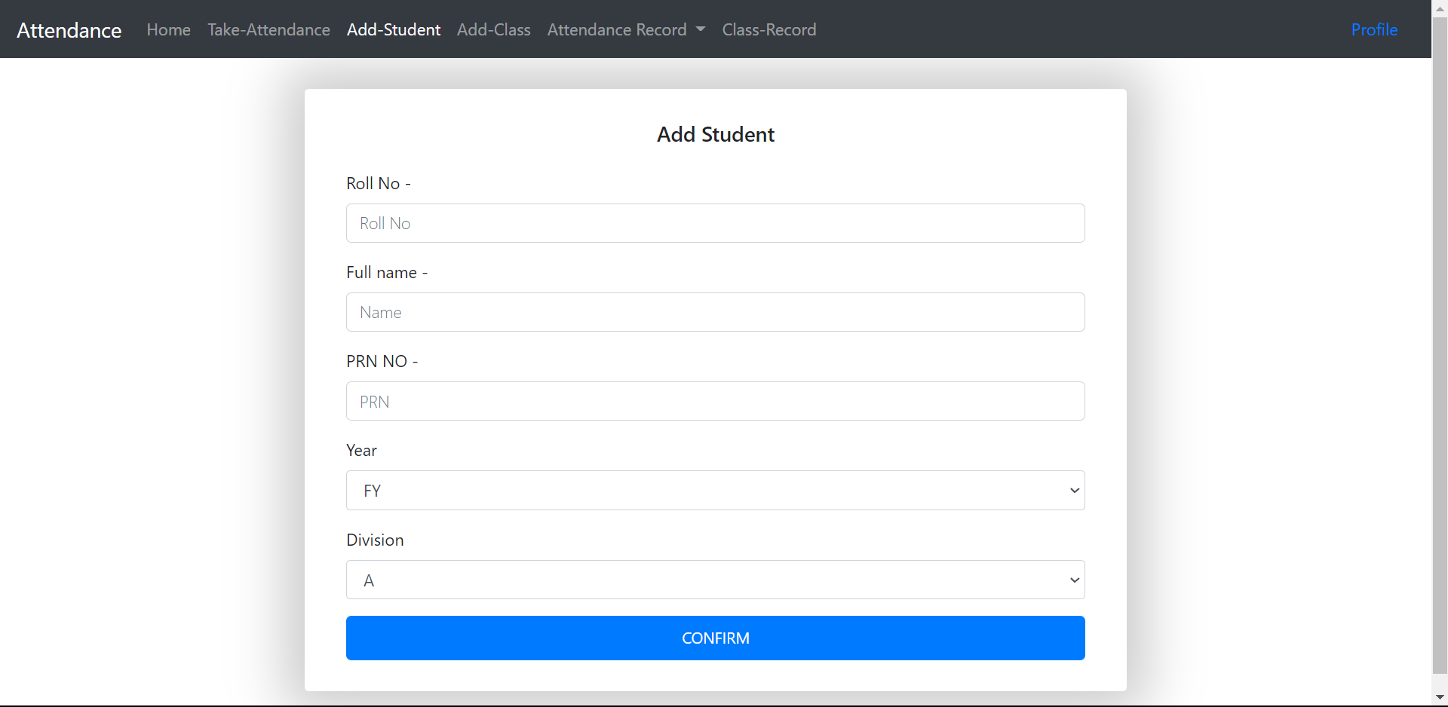

Screenshot 3.3.5 Add Student Page

3.3.6 Attendance by Subject Page

Screenshot 3.3.6 Attendance by Subject Page

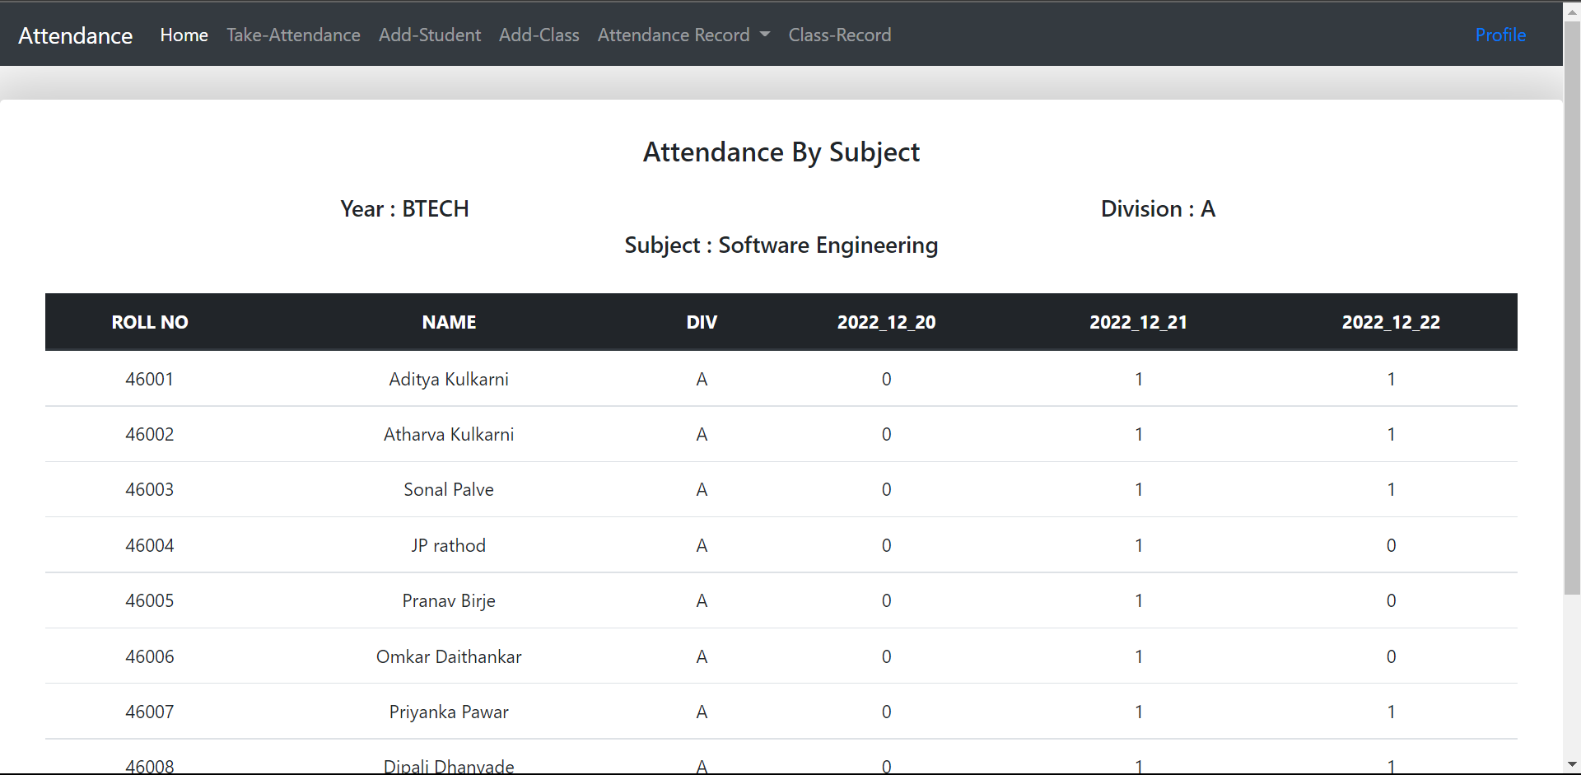

Screenshot 3.3.7 Attendance by Subject Page (count)

3.3.7 Attendance by Class Page

Screenshot 3.3.8 Attendance by Class Page

Screenshot 3.3.9 Attendance by Class Page (count)

3.3.6 Class Record Page

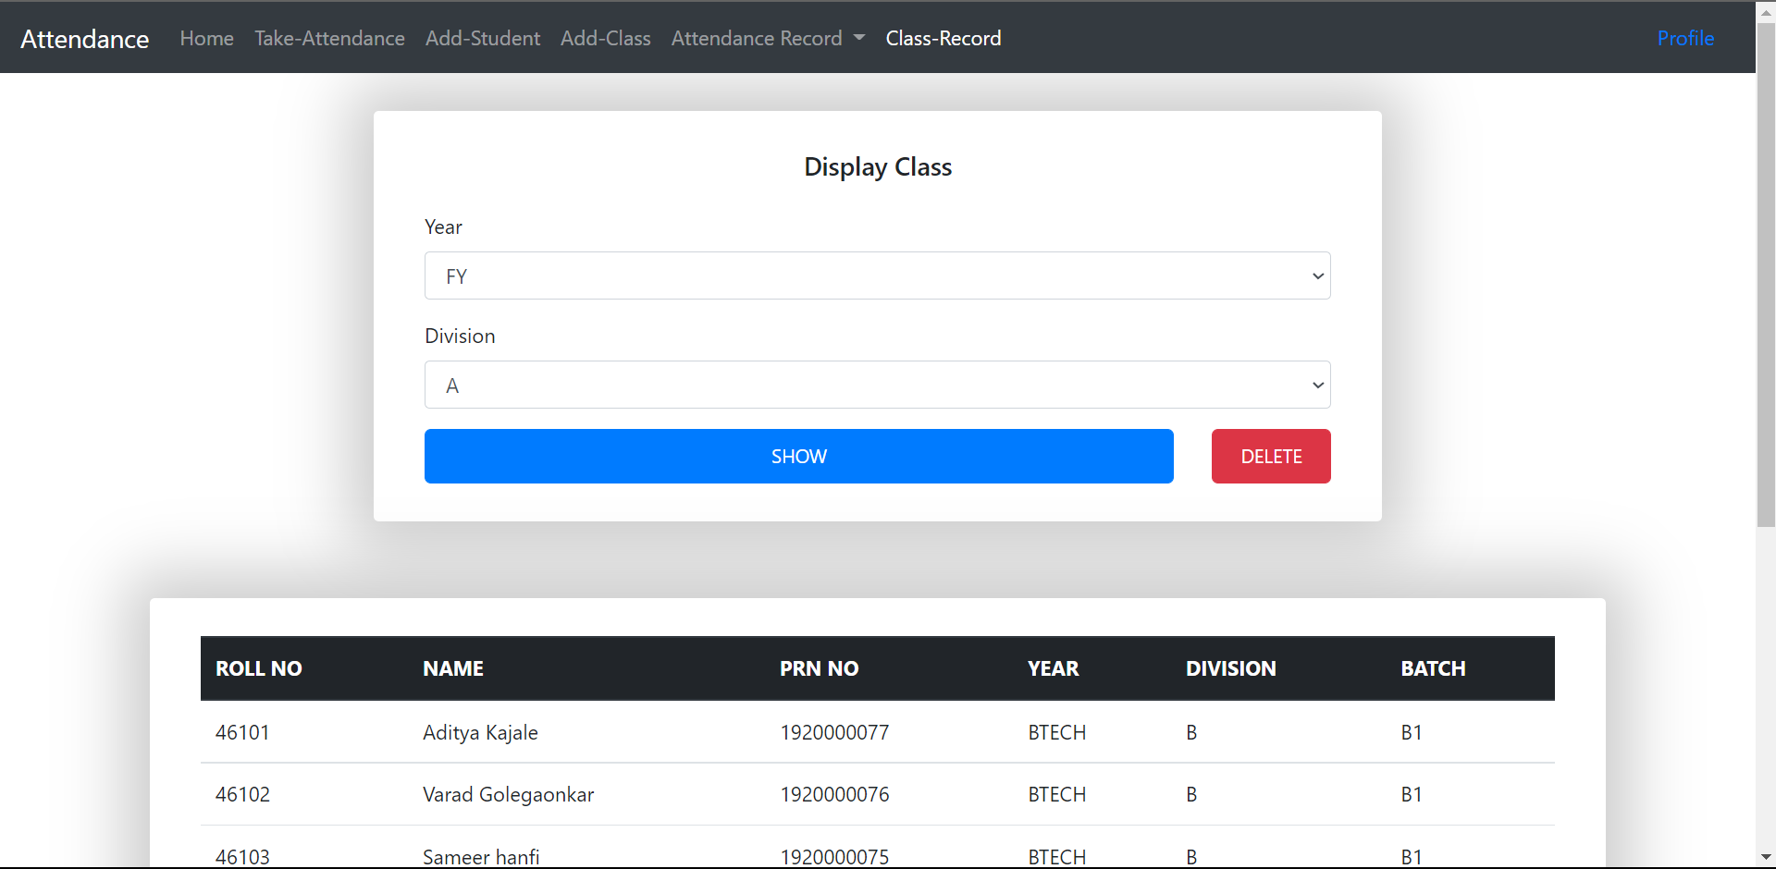

Screenshot 3.3.10 Class Record Page

3.3.7 Profile Page

Screenshot 3.3.11 Profile Page

3.3.8 Manage Faculty Page

Screenshot 3.3.12 Manage Faculty Page

Screenshot 3.3.13 Add Remove Subject Page

3.3.9 Manage Subject Page

Screenshot 3.3.14 Manage Subject Page

**3.4 Data Flow Diagram**

**3.4.1 DFD level 0:**



ATTANDANCE

MANAGEMENT

SYSTEM

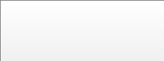

USER

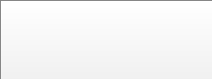

REPORT

DATABASE

Figure 3.4.1 DFD level 1

**3.4.2 DFD level 1:**

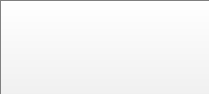

PERSON



LOGIN



AUTHENDICAT

ION

USER

DATABASE



ADMIN

ACCESS



STAFF

ACCESS

ENTRY

INVALID

UID / PWD

CHECK

Figure 3.4.2 DFD level 1

**3.5 DFD level 2:**

**3.5.1 Admin:**



ALLOCATION

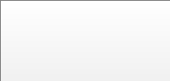

ADMIN



VIEW



UPDATE

STUDENTS

STAFFS

ATTANDANCE



ACCESS

Stored data from

database

Get details

contribution

contribution

contribution

Get details

Stored data fr

o

m

database

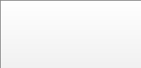

REPORT

Figure 3.5.1 DFD level 2 Admin

**3.5.2 Faculty:**

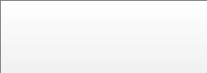

USER



Attendance

entry

Attendance table

Input Attendance

Stored attendance

Get all student

attendance



UPDATE

ATTENDANCE

Stored attendance

Update attendance

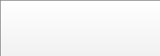

REPORT

Figure 3.5.2 DFD level 2 Faculty

**3.6 SYSTEM DESIGN:**

**3.6.1 Content Diagram:**

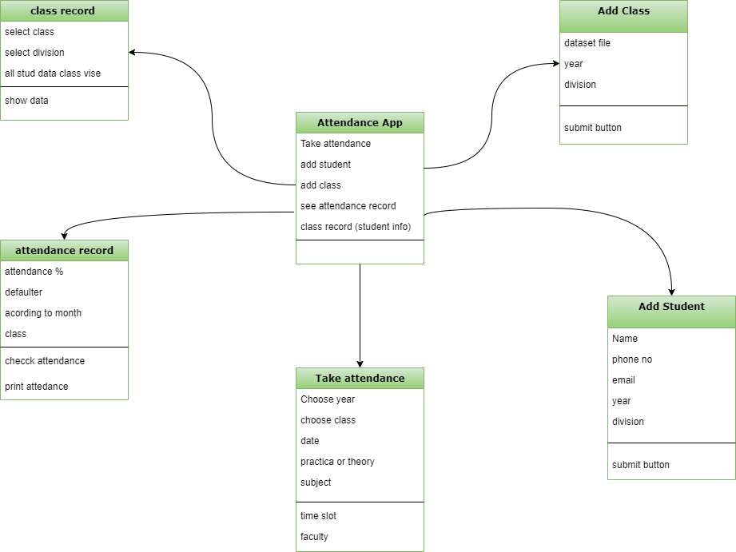

Figure 3.6.1 Content Diagram

**3.6.2 Database Design**

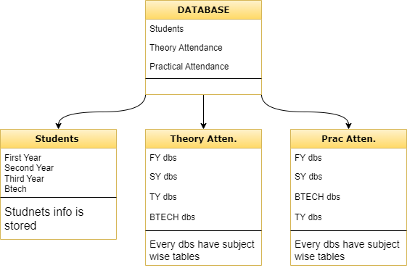

Figure 3.6.2 Database Design

**3.6.3 Database Design Table**

**3.6.3.1 Faculty Login Account**

* Faculties can register their log in details

|  |  |  |  |
| --- | --- | --- | --- |
| **Field** | **Datatype** | **Constraint** | **Description** |
| ID | INT | Primary | Primary id assigned to faculty |
| Name | Varchar (50) | Not Null | Name of Faculty |
| Password | Varchar (20) | Not Null | Pass of Faculty |
| Email | Varchar (50) | Not Null | Email of Faculty |

Table 3.6.3.1 Faculty Login Account

**3.6.3.2 Student Database**

* Every student database have B.Tech, TY, SY, FY
* Students’ data is stored

|  |  |  |  |
| --- | --- | --- | --- |
| **Field** | **Datatype** | **Constraint** | **Description** |
| Roll No | INT | Primary Key | Roll no of student |
| Name | Varchar (50) | Not Null | Name no of student |
| PRN Number | INT | Not Null | PRN no of student |
| Year | Text | Not Null | Year of study of student |
| Division | Text | Not Null | Division of Student |
| Batch | Varchar (5) | Not Null | Batch of student |

Table 3.6.3.1 Student Database

**3.6.3.3** **Attendance Database**

* The attendance is taken in two formats theory and practical.
* Those two types of databases have tables assigned according to every subject.
* Every table of subject stores data of present as 1 and absent as 0.

|  |  |  |  |
| --- | --- | --- | --- |
| **Field** | **Datatype** | **Constraint** | **Description** |
| Roll No | INT | Primary Key | Roll no of student |
| Name | Varchar (50) | Not Null | Name no of student |
| Division | Text | Not Null | Division of Student |
| Date | INT | Not Null | Present for 1 and absent for 0 |
| .  .  .  .  .  . | .  .  .  .  .  .  . | .  .  .  .  .  .  . | .  .  .  .  .  .  . |
| . | . | . | . |

Table 3.6.3.3 Attendance Database

**3.7** **System flow Diagram**

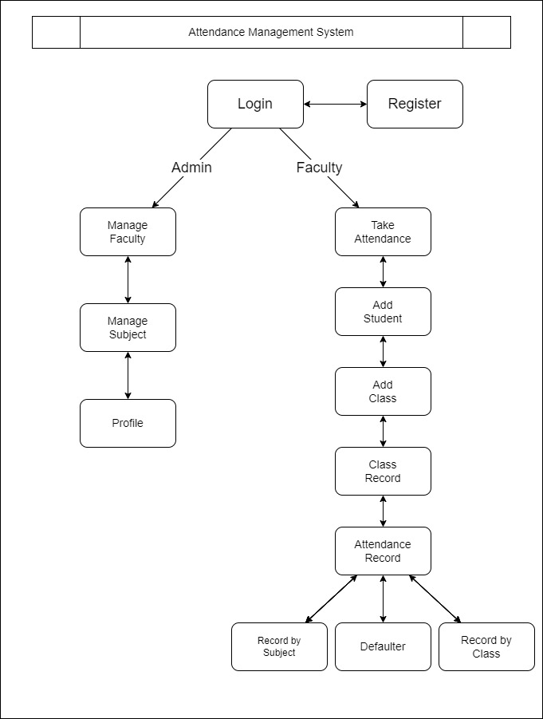

Figure 3.7 System flow Diagram

**4. PERFORMANCE EVALUATION**

## 4.1 Development Tools and Technologies

**Visual Studio Code:**

Microsoft Visual Studio is an [integrated development environment](https://en.wikipedia.org/wiki/Integrated_development_environment) (IDE) from Microsoft. It is used to develop [console](https://en.wikipedia.org/wiki/Console_application) and graphical use [interface](https://en.wikipedia.org/wiki/Graphical_user_interface) [applications](https://en.wikipedia.org/wiki/Application_software) along with [Windows Forms](https://en.wikipedia.org/wiki/Windows_Forms) or [WPF](https://en.wikipedia.org/wiki/Windows_Presentation_Foundation) applications, [web sites,](https://en.wikipedia.org/wiki/Web_site) [web applications,](https://en.wikipedia.org/wiki/Web_application) and [web services](https://en.wikipedia.org/wiki/Web_service) in both code together with [managed code](https://en.wikipedia.org/wiki/Managed_code) for all platforms supported by [Microsoft Windows,](https://en.wikipedia.org/wiki/Microsoft_Windows) [Windows Mobile,](https://en.wikipedia.org/wiki/Windows_Mobile) [Windows CE,](https://en.wikipedia.org/wiki/Windows_CE) [.NET Framework,](https://en.wikipedia.org/wiki/.NET_Framework) [.NET Compact Framework](https://en.wikipedia.org/wiki/.NET_Compact_Framework) and [Microsoft Silver light.](https://en.wikipedia.org/wiki/Microsoft_Silverlight)

Visual Studio supports different [programming languages](https://en.wikipedia.org/wiki/Programming_language) by means of language services, which allow the code editor and debugger to support (to varying degrees) nearly

any programming language, provided a language-specific service exists.

Visual Studio also includes a web-site editor and designer that allows web pages to be authored by dragging and dropping widgets. It is used for developing VB.NET application efficiently to get input and output design easiest one. It will be run at windows application-based services provide the user.

**Python:**

Python is an interpreted, object-oriented, high-level programming language with dynamic semantics. Its high-level built-in data structures, combined with dynamic typing and dynamic binding, make it very attractive for Rapid Application Development, as well as for use as a scripting or glue language to connect existing components together. Python's simple, easy to learn syntax emphasizes readability and therefore reduces the cost of program maintenance. Python supports modules and packages, which encourages program modularity and code reuse. The Python interpreter and the extensive standard library are available in source or binary form without charge for all major platforms and can be freely distributed.

Often, programmers fall in love with Python because of the increased productivity it provides. Since there is no compilation step, the edit-test-debug cycle is incredibly fast. Debugging Python programs is easy: a bug or bad input will never cause a segmentation fault. Instead, when the interpreter discovers an error, it raises an exception. When the program doesn't catch the exception, the interpreter prints a stack trace. A source level debugger allows inspection of local and global variables, evaluation of arbitrary expressions, setting breakpoints, stepping through the code a line at a time, and so on. The debugger is written in Python itself, testifying to Python's introspective power. On the other hand, often the quickest way to debug a program is to add a few print statements to the source: the fast edit-test-debug cycle makes this simple approach very effective.

Python is used in many application domains. Here's a sampling.

1. The Python package index lists thousands of third-party modules for Python.
2. Web and Internet Development

Python offers many choices for web development:

* Frameworks such as Django and Pyramid.
* Micro-frameworks such as Flask and Bottle.
* Advanced content management systems such as Plone and Django CMS.

IO management

* Windows and Web Controls
* Database access
* Multithreading
* Remoting
* Reflections

**Flask:**

Flask is a web framework, it’s a Python module that lets you develop web applications easily. It’s having a small and easy-to-extend core: it’s a microframework that doesn’t include an ORM (Object Relational Manager) or such features.

It does have many cool features like URL routing, template engine. It is a WSGI web app framework.

Flask is a lightweight WSGI web application framework. It is designed to make getting started quick and easy, with the ability to scale up to complex applications. It began as a simple wrapper around Werke and Jinja and has become one of the most popular Python web application frameworks.

Flask offers suggestions but doesn’t enforce any dependencies or project layout. It is up to the developer to choose the tools and libraries they want to use. There are many extensions provided by the community that make adding new functionality easy.

**from** flask **import** Flask

app = Flask**(**__name__**)**

@app.route**(**"/"**)**

**def** hello_world**():**

**return** "<p>Hello, World!</p>"

To run the application, use the flask command or python -m flask. You need to tell the Flask where your application is with the --app option.

$ flask --app hello run

* Serving Flask app 'hello'

* Running on http://127.0.0.1:5000 (Press CTRL+C to quit)

This launches a very simple built in server, which is good enough for testing but probably not what you want to use in production. For deployment options see Deploying to Production.

Now head over to http://127.0.0.1:5000/, and you should see your hello world greeting.

**4.2 Problem Definition:**

This system developed will reduce the manual work and avoid redundant data. By maintaining the attendance manually, then efficient reports cannot be generated. The system can generate efficient weekly, consolidate report based on the attendance. As the attendances are maintained in registers it has been a tough task for admin and staff to maintain for long time. Instead, the software can keep long and retrieve the information when needed.

## 4.3 Project Overview

Attendance Management System basically has two main modules for proper

functioning

* Admin module is having rights for creating any new entry of faculty and student details.
* User has a right of making daily attendance, generating report. Attendance report can be taken by given details of student details, date, class.

## 4.4 Module Description

The system should be designed in such a way that only authorized people should be allowed to access some modules. The records should be modified by only administrators and no one else. The user should always be in control of the application and not the vice versa.

The user interface should be consistent so that the user can handle the application with ease and speed. The application should be visually, conceptually clear.

**4.4.1 Administrator Module:**

* **Staff Details:**
* It helps to allot the subject and the subject code to the staffs.
* It provides the facility to have a username and password to the staffs
* **Subject Management**
* When University introduces new subject admin can add new subject in the system.
* **Attendance details:**
* It will be makes to the attendance database all students. Entered attendance to store in the database subject, period wise into the date.
* It will help us to the get report of weekly and consolidate of the attendance.

**Report details:**

Report can be taken by daily, weekly and consolidate:

* Weekly report gets all hour details of attendance starting date to ending date and display the status
* Attendance by the subject can be seen in attendance record page in which attendance by date can be seen.
* Attendance by the class can be seen in which count of every subject attendance is shown.
* Defaulter list can see in which student with attendance lower than the required percentage is given in red.
* Consolidate report get all student attendance details starting date to ending date status help for the eligibility criteria of the student to attend the examination.

**4.4.2 Staffs Module:**

* **Attendance details:** 
  + It assists the staff to mark attendance to the students for their subject. This will authenticate the staff before making the entry.
* **Take Attendance:** 
  + Take attendance of subject which are assigned to the faculty by the admin
* **Report details:** 
  + Weekly report gets all hour details of attendance starting date to ending date and display the status
  + Attendance by the subject can be seen in attendance record page in which attendance by date can be seen.
  + Attendance by the class can be seen in which count of every subject attendance is shown.
  + Defaulter list can see in which student with attendance lower than the required percentage is given in red.
  + Consolidate report get all student attendance details starting date to ending date status help for the eligibility criteria of the student to attend the examination.

# 4.5 Testing Introduction

Once source code has been generated, software must be tested to uncover (and correct) as many errors as possible before delivery to customer. Our goal is to design a series of test cases that have a high likelihood of finding errors. To uncover the errors software techniques are used. These techniques provide systematic guidance for designing test that

* + - Exercise the internal logic of software components, and
    - Exercise the input and output domains of the program to uncover errors In program function, behaviour and performance.

**Steps:** Software is tested from two different perspectives:

* + - 1. Internal program logic is exercised using ―White box‖ test case design

Techniques.

* + - 1. Software requirements are exercised using ―block box‖ test case

Design techniques.

In both cases, the intent is to find the maximum number of errors with the Minimum amount of effort and time.

### **4.5.1 Testing Methodologies:**

A strategy for software testing must accommodate low-level tests that are necessary to verify that a small source code segment has been correctly implemented as well as high-level tests that validate major system functions against customer requirements. A strategy must provide guidance for the practitioner and a set of milestones for the manager. Because the steps of the test strategy occur at a time when deadline pressure begins to rise, progress must be measurable and problems must surface as early as possible. Following testing techniques are well known and the same strategy is adopted during this project testing.

**Unit testing:**

Unit testing focuses verification effort on the smallest unit of software design- the software component or module. The unit test is white-box oriented. The unit testing implemented in every module of student attendance management System. by giving correct manual input to the system, the data are stored in database and retrieved. If you want required module to access input or get the output from the End user. any error will accrue the time will provide handler to show what type of error will accrued.

**System testing:**

System testing is a series of different tests whose primary purpose is to fully exercise the computer-based system. Below we have described the two types of testing which have been taken for this project. it is to check all modules worked on input basis. if you want change any values or inputs will change all information. so specified input is must.

**Performance Testing**

Performance testing is designed to test the run-time performance of software within the context of an integrated system. Performance testing occurs throughout all steps in the testing process. Even at the unit level, the performance of an individual module may be assessed as white-box tests are conducted.

This project reduces attendance table, codes. it will generate report fast.no have extra time or waiting of results. entered correct data will show result few millisecond. just used only low memory of our system. Automatically do not getting access at another software. Get user permission and access to other application.

**4.5.2 Test cases**

Test case is an object for execution for other modules in the architecture does not represent any interaction by itself. A test case is a set of sequential steps to execute a test operating on a set of predefined inputs to produce certain expected outputs. There are two types of test cases: -manual and automated. A manual test case is executed manually while an automated test case is executed using automation.

In system testing, test data should cover the possible values of each parameter based on the requirements. Since testing every value is impractical, a few values should be chosen from each equivalence class. An equivalence class is a set of values that should all be treated the same.

Ideally, test cases that check error conditions are written separately from the functional test cases and should have steps to verify the error messages and logs. Realistically, if functional test cases are not yet written, it is ok for testers to check for error conditions when performing normal functional test cases. It should be clear which test data if any is expected to trigger errors.

**4.6 System Implementation Purpose**

System implementation is the important stage of project when the theoretical design is tuned into practical system. The main stages in the implementation are as follows:

1. Planning
2. Training
3. System testing and
4. Changeover Planning

Planning is the first task in the system implementation. At the time of implementation of any system people from different departments and system analysis involve. They are confirmed to practical problem of controlling various activities of people outside their own data processing departments.

The line managers controlled through an implementation coordinating committee. The committee considers ideas, problems, and complaints of user department, it must also consider:

1. The implication of system environment
2. Self-selection and allocation for implementation tasks
3. Consultation with unions and resources available
4. Standby facilities and channels of communication

Student Attendance management system will implement student details, staff handle subjects’ details, separate login details, timetable details. It will used to entered subject wise attendance. This application elaborates attendance table generate weekly, consolidate report provide to the End user. Mostly this application will calculate date wise attendance. To select starting date to end date generate reports at the time of activities.

## 4.7 System Maintenance

Software maintenance is far more than finding mistakes. Provision must be made for environment changes, which may affect either the computer, or other parts of the computer-based systems. Such activity is normally called maintenance. It includes both the improvement of the system functions and the corrections of faults, which arise during the operation of a new system.

It may involve the continuing involvement of a large proportion of computer department recourses. The main task may be to adapt existing systems in a changing environment.

Back up for the entire database files are taken and stored in storage devices like flash drives, pen drives and disks so that it is possible to restore the system at the earliest. If there is a breakdown or collapse, then the system gives provision to restore database files. Storing data in a separate secondary device leads to an effective and efficient maintains of the system. The nominated person has sufficient knowledge of the organization’s computer passed based system to be able to judge the relevance of each proposed change.

# 5. CONCLUSION

## 5.1 Conclusion

To conclude, Project Data Grid works like a component which can access all the databases and picks up different functions. It overcomes the many limitations incorporated in the attendance.

* Easy implementation Environment
* Generate report Flexibly
* Generate defaulter list

## 5.2 Scope for future development

The project has a very vast scope in future. The project can be implemented on intranet in future. Project can be updated in near future as and when requirement for the same arises, as it is very flexible in terms of expansion. With the proposed software of database Space Manager ready and fully functional the client is now able to manage and hence run the entire work in a much better, accurate and error free manner. The following

are the future scope for the project.

1. Discontinue of student eliminate potential attendance.
2. Bar code Reader based attendance system.
3. Individual Attendance system with photo using Student login.

# REFERENCES

## WEBSITES

* 10 Nov 2022 07:00 pm <http://www.stackoverflow.com>
* 19 Nov 2022 09:00 pm <http://www.codeproject.com>
* 24 Nov 2022 11:00 pm [https://www.tutorialspoint.com/software_engineering/](https://www.tutorialspoint.com/software_engineering/software_project_management.htm)
* 02 Dec 2022 08:00 pm <http://www.ignousolvedassignments.com>
* 13 Dec 2022 02:00 pm

<http://feedburner.google.com/fb/a/mailverify?uri=ignousolvedassignments_com>

* 15 Dec 2022 07:00 am <https://www.slideshare.net/rhspcte/software-engineering-ebook-roger-s-pressman>
* 19 Dec 2022 11:00 pm [www.cse.msu.edu/~cse870/IEEEXplore-SRS-template.pdf](http://www.cse.msu.edu/~cse870/IEEEXplore-SRS-template.pdf)

**ACKNOWLEDGEMENT**

I would like to place on record my deep sense of gratitude to Prof. S. B. Kalyankar, HOD-Dept. of Computer Science and Engineering, Deogiri Institute of Engineering, and management Studies Aurangabad, for his generous guidance, help and useful suggestions.

I express my sincere gratitude to Prof. Gopal Burkul, Dept. of Computer Science and Engineering, Deogiri Institute of Engineering, and management Studies Aurangabad, for his stimulating guidance, continuous encouragement, and supervision throughout the course of present work.

I am extremely thankful to Dr. Ulhas Shiurkar, Director, Deogiri Institute of Engineering, and management Studies Aurangabad, for providing me infrastructural facilities to work in, without which this work would not have been possible.

**Signature(s) of Student**

Aditya Rameshwar Kajale